**Educational Organization Using Servicenow**

**Project Overview**

The Naan Mudhalvan project aims to enhance employability, innovation, and entrepreneurship skills of students through hands-on, project-based learning. ServiceNow will be utilized to create a centralized platform for managing student information, course management, faculty and staff management, and learning management system integration

**Key Features**

**Student Information System**: Manage student demographics, enrollment, and academic records.

**Course Management**: Develop and manage course curricula, scheduling, and grading.

**Faculty and Staff Management**: Manage faculty and staff information, schedules, and performance evaluations.

**Learning Management System Integration**: Integrate ServiceNow with an LMS to provide a seamless learning experience.

**Reporting and Analytics**: Track student performance, course effectiveness, and faculty productivity.

**Project Objectives**

* Familiarize students with ServiceNow and its applications.
* Develop practical skills in using ServiceNow to solve real-world problems.
* Enhance employability and prepare students for industry demand

**SETTING UP SERVICENOW INSTANCE**

* The "Setting Up ServiceNow Instance" module guides users to create their own ServiceNow developer instance.
* It involves signing up on the ServiceNow Developer site, requesting a personal instance, filling details, and receiving login credentials via email.
* Once logged in, users can access and navigate ServiceNow For further project development

**CREATE A NEW UPDATE SET**

Step 1:Log in to your ServiceNow instance. Navigate to System Update Sets Update Sets

Step 2:Click New

Step 3:Enter a Name for your update set (e.g., "Welcome to ServiceNow Update Set").

Step 4:Enter a Description for your update set

Step 5:Click Submit

**CREATING A TABLE**

**Creating Salesforce Table**

* All >> Tables
* Click on new

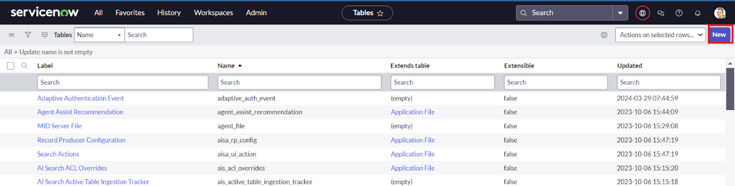

* Enter the Label(Anything you want): Salesforce >> Click on Name it will Automatically generate Api name.
* Create columns as given below,Double Click on Column label and Enter the Column labels and click on the tick mark >> Give Type as given
* For “Admin Number” Give Display as True and right click on the toggle bar on top >> save
* Click on controls >> Enable Extensible
* Click on “Admin Number” column, In Related Links Click on Advanced View >> Default View (Enable Use dynamic default) >> select Get Next Padded Number in Dynamic default value >> Update 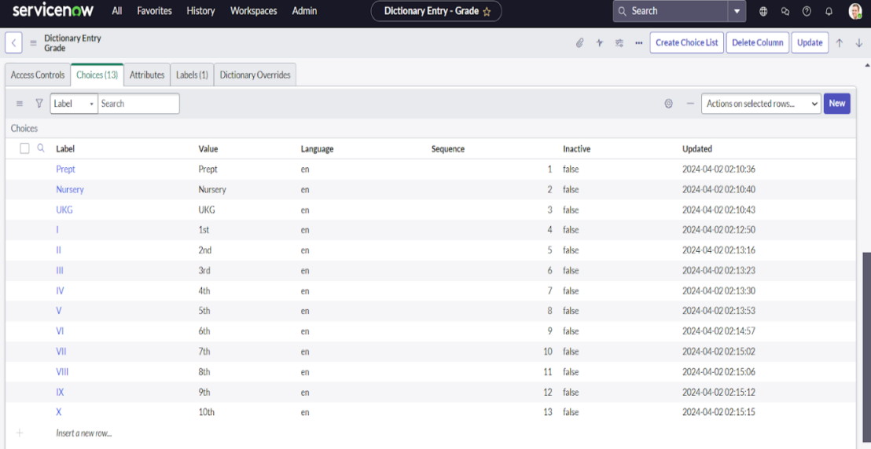
* Click on “Grade” Column >> Click on Choices and give Label,Value and Sequence as given below

**Creating Admission Table**

* Create an Admission Table with Columns given.
* Select Extends Table >> Salesforce and also Select Add module to menu >> Salesforce.
* Create Fields as shown

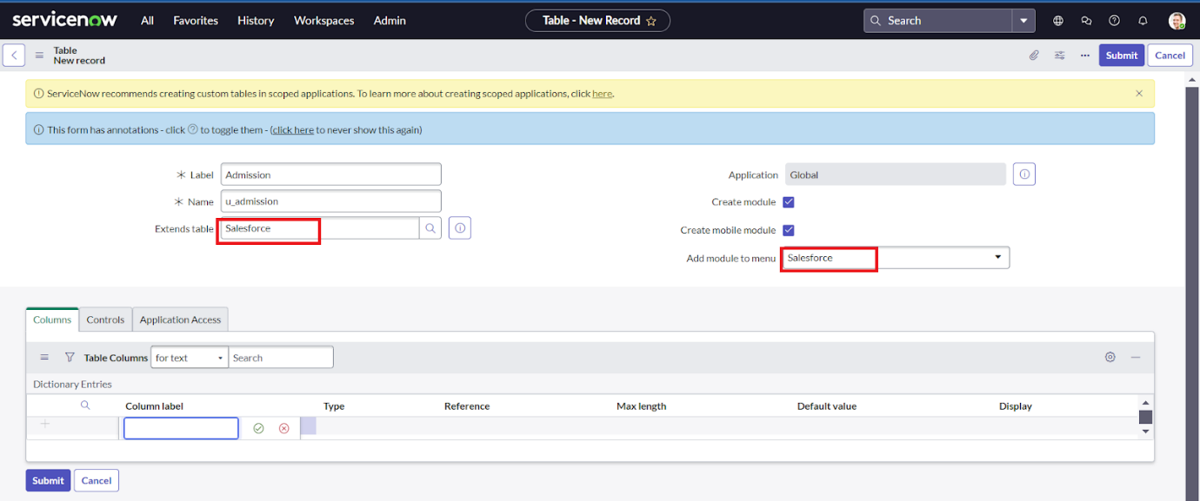

* **Create choice for Pincode as:**

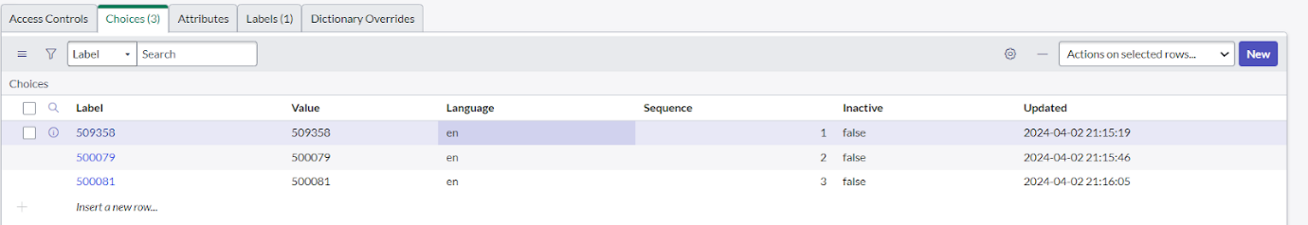

* **Create choice for Purpose of Join as:**

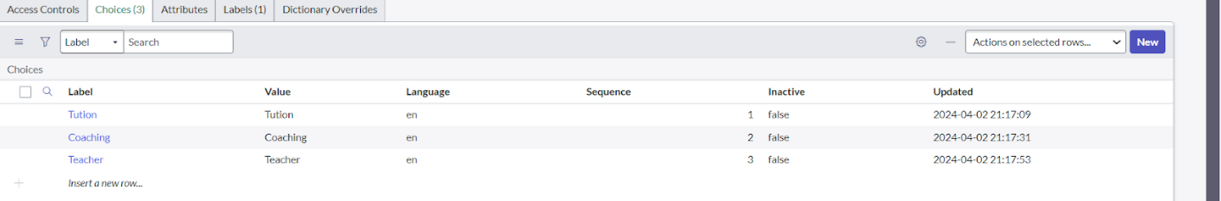

* **Create choice for School as:**

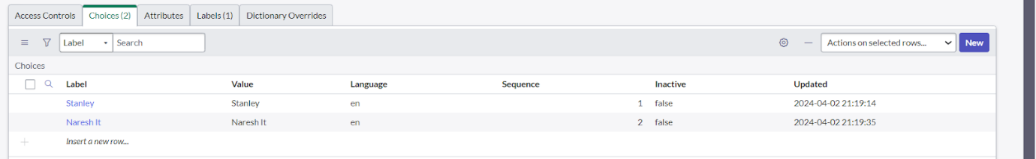

* **Create choice for School Area as:**

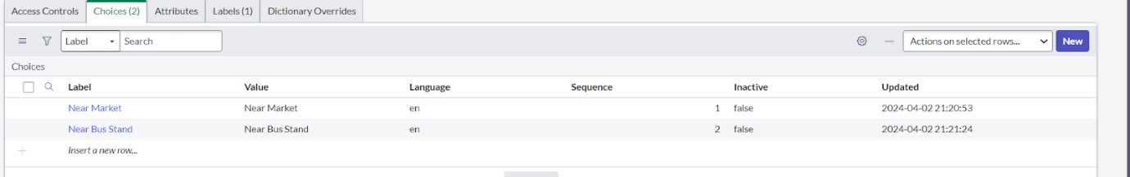

**FORM LAYOUT**

**Configuring Table form for Student Progress Table**

* In the Student Progress Table Page , Click on Layout form .

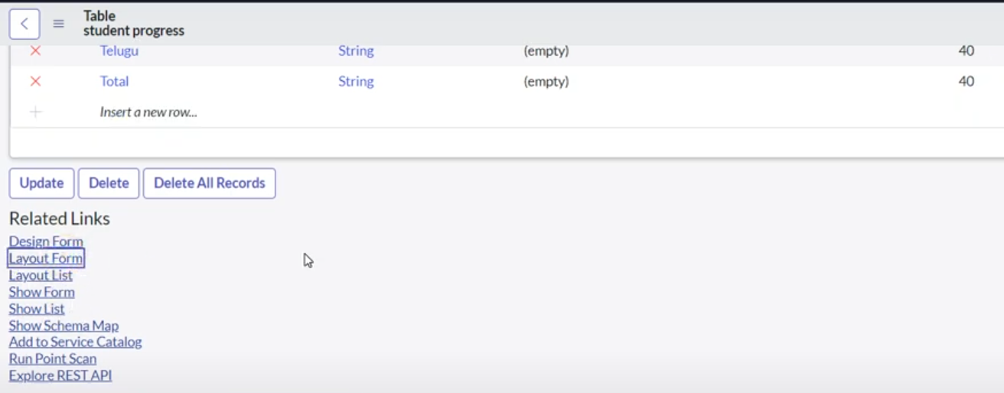

* Click on Admission Number [+] .
* Select below Admission Number fields in Available side and send it to selected side as below >> save.

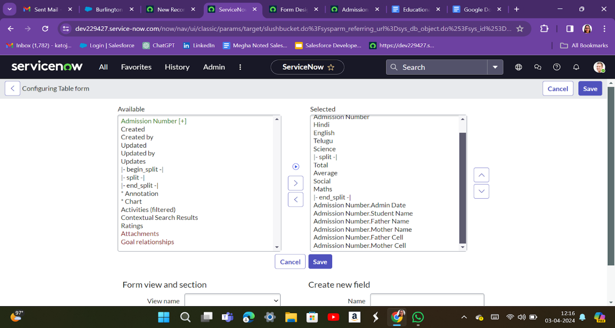

**FORM DESIGN**

**Creating Form Design for Salesforce Table**

1. All >> System Definition >> Tables .
2. In Label Search for Salesforce and open .

3.Right Click on top Toggle >> Configure >> Form Design.

1. In drop down select Salesforce(u_salesforce).
2. Drag and drop the fields to the left side as below.

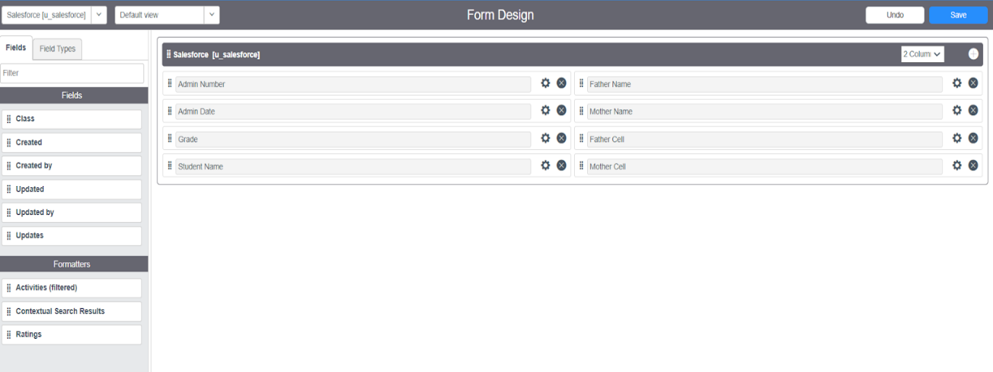

**Creating Form Design for Admission Table**

Follow the same steps as Activity1,Configure the fields as below and Save.

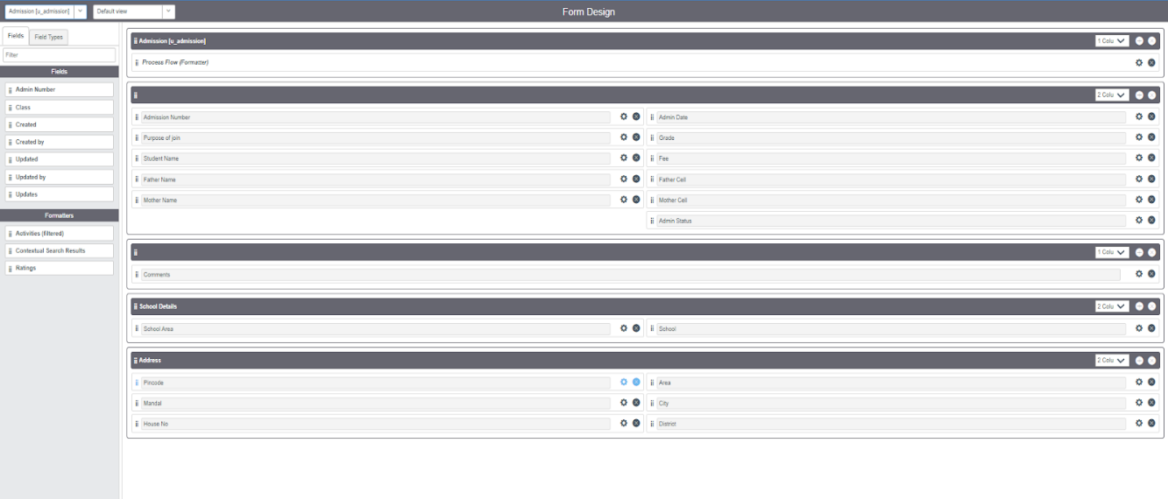

**Creating Form Design for Student progress Table**

Follow the same steps as Activity1,Configure the fields as below and Save.

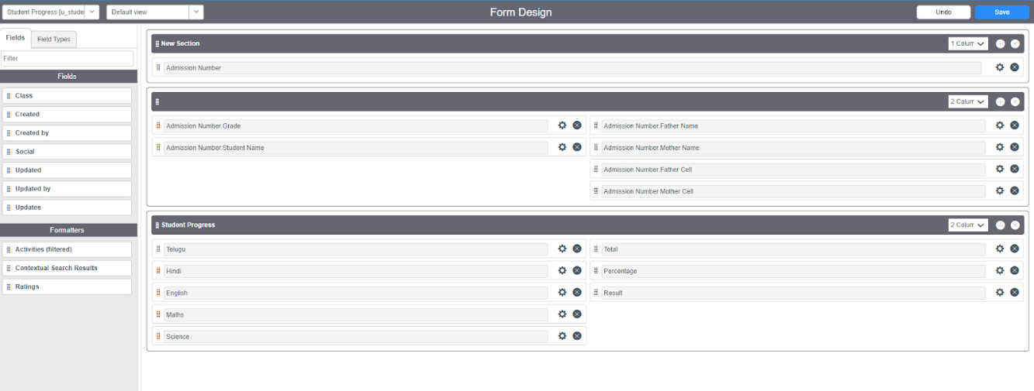

**NUMBER MAINTENANCE**

**Creating Number Maintenance for Admin Number**

* All >> Number Maintenance >> New
* Fill the details >> Submit.

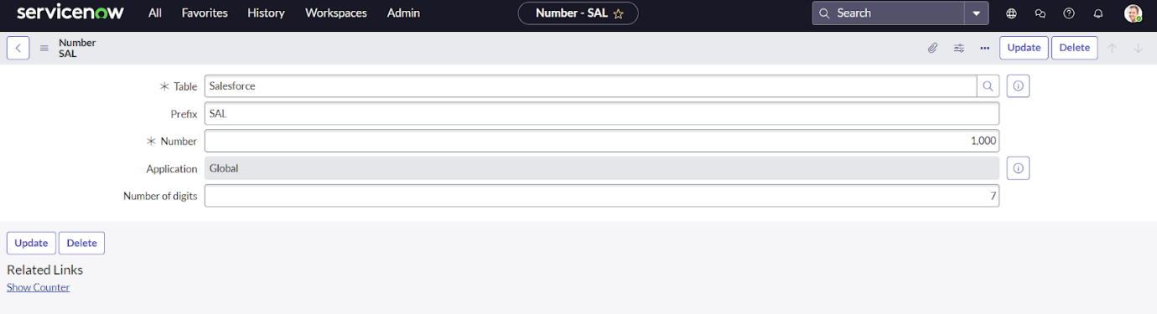

**PROCESS FLOW**

### Creating Process Flow For Admission Table

* All >> Process Flow>> New.
* Fill the Details as given Below
* Right Click on toggle and click on the save .

Replace the Name and Label as below and click on Insert on stay.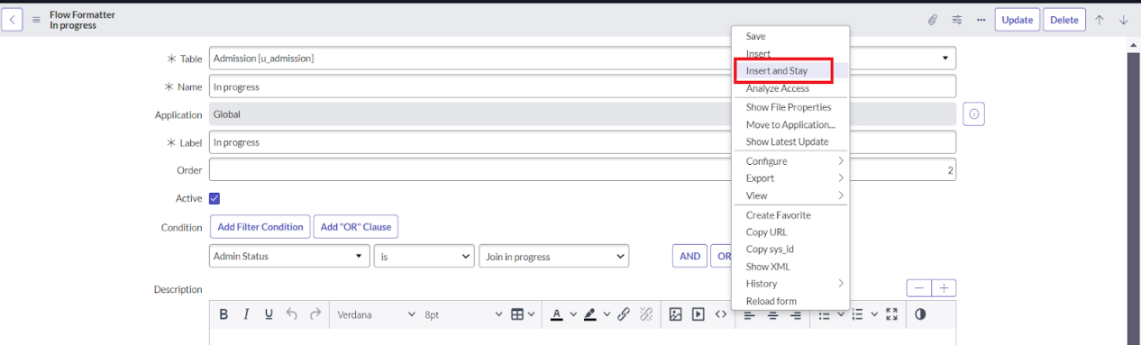

* Replace the Name and Label in order and click on Insert on stay.

Joined >> Rejected >> Rejoined >> Closed >> Cancelled.

* Order should be New >> InProgress >> Joined >> Rejected >> Rejoined >> Closed >> Cancelled.

**CLIENT SCRIPT**

### Creating “Auto Populate” Client Scripts For Admission Table

* All >> Client Scripts >> New.
* Fill the Details as given.

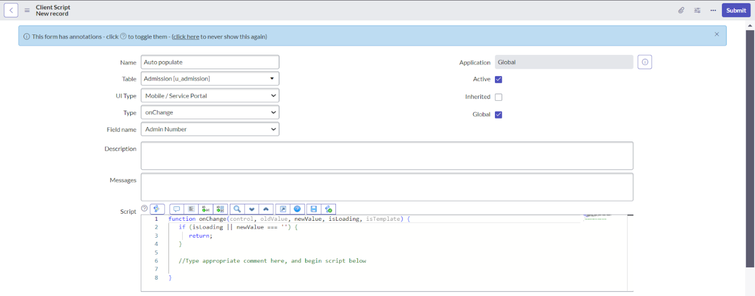

* Write the Code as below, Enable Isolate script and Save.

function onChange(control, oldValue, newValue, isLoading, isTemplate) {

   if (isLoading || newValue === '') {

   return;

   }

   //Type appropriate comment here, and begin script below

   var a = g_form.getReference('u_admission_number');

   g_form.setValue('u_admin_date',a.u_admin_date);

   g_form.setValue('u_grade',a.u_grade);

   g_form.setValue('u_student_name',a.u_student_name);

   g_form.setValue('u_father_name',a.u_father_name);

   g_form.setValue('u_mother_name',a.u_mother_name);

   g_form.setValue('u_father_cell',a.u_father_cell);

   g_form.setValue('u_mother_cell',a.u_mother_cell);

   g_form.setDisabled('u_admin_date',a.u_admin_date);

   g_form.setDisabled('u_grade',a.u_grade);

   g_form.setDisabled('u_student_name',a.u_student_name);

   g_form.setDisabled('u_father_name',a.u_father_name);

   g_form.setDisabled('u_mother_name',a.u_mother_name);

   g_form.setDisabled('u_father_cell',a.u_father_cell);

   g_form.setDisabled('u_mother_cell',a.u_mother_cell);

}

**Note**: Make sure the Field names should be the same as you created .

**Follow this steps for creating this tables**

### Creating “Pincode Update” Client Scripts For Admission Table

### Creating “Disable Fields” Client Scripts For Student Progress Table

### Creating “Total Update” Client Scripts For Student Progress Table

### Creating “Result” Client Scripts For Student Progress Table

### Creating “Percentage” Client Scripts For Student Progress Table

### **RESULT**

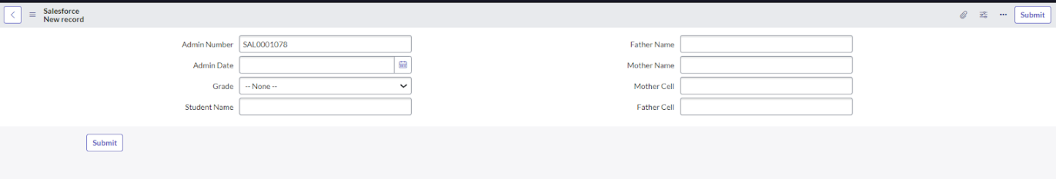

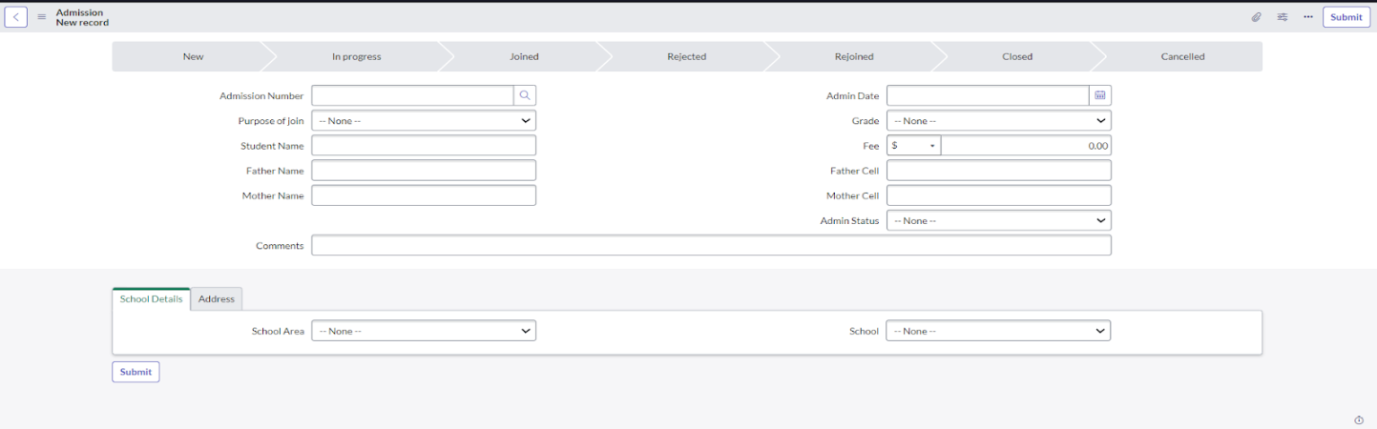

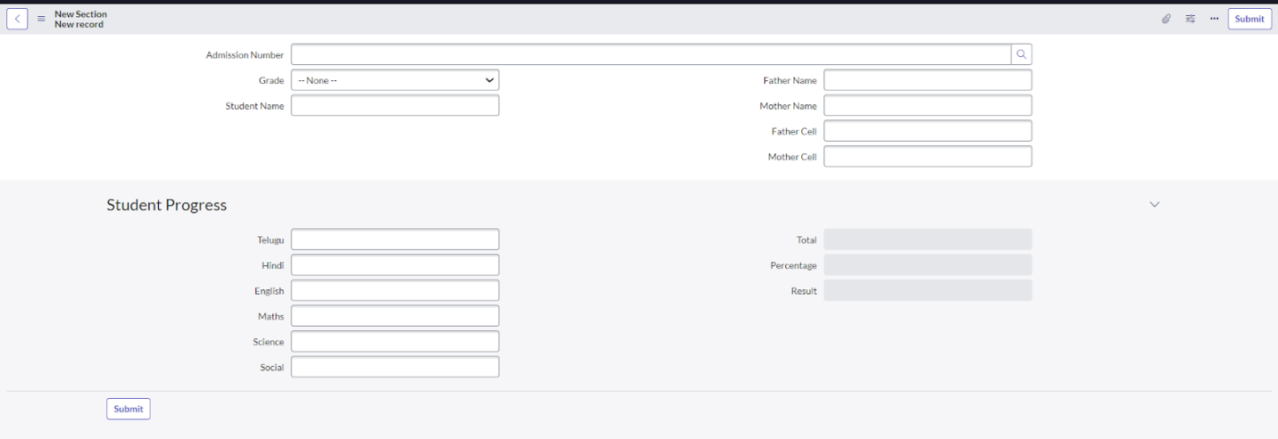

Conclusion

The Naan Mudhalvan project, powered by ServiceNow, empowers students with hands-on experience and industry-level training. By harnessing ServiceNow's capabilities, students develop essential skills like critical thinking, problem-solving, and teamwork, making them highly employable and industry-ready. This project bridges the gap between academia and industry, preparing students for real world challenges and opportunities

**THANK YOU**

TEAM MEMBERS:

**S.Umamageshwari**

**K.Vanisree**

**R.Yuvasri**